STOP

A retreat for women who just want everything to stop so they can find themselves again.

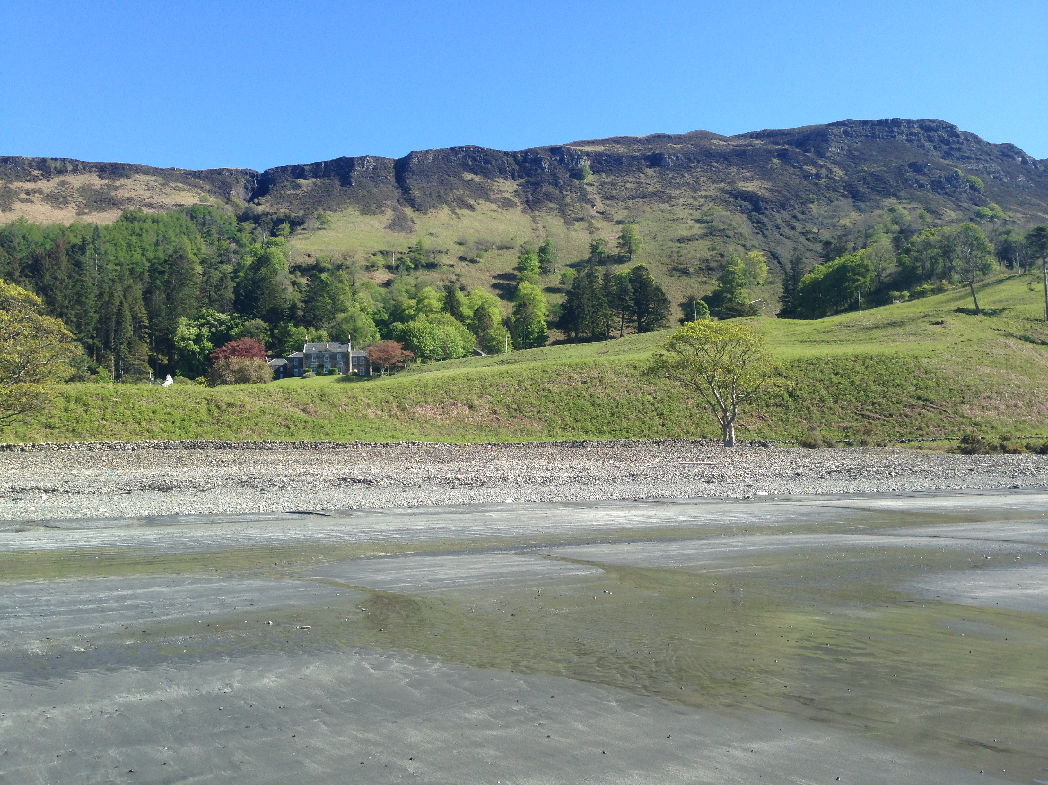

Women are notoriously bad at putting themselves first.

We often hold everything together whilst internally falling apart.

We go through life saying:

I’ll have time to …………… ‘when the children are older’, or ‘when my career takes off’ or ‘when I retire’.

If this is you - STOP right now.

You deserve some ‘me’ time
You deserve some R and R
You deserve some space in which to breathe, to discover and to ask yourself
Who am I?

On April 22nd 2018, we have arranged a 5 day retreat for 14 women at Carsaig House, Isle of Mull (see photo).

This includes:

Trust – 2 day Leadership Embodiment Level One - using your body and its energies to connect you to your true self and purpose. A beautiful combination of Aikido and mindfulness which will teach you new ways to respond to life’s challenges. (this course alone usually costs £300 excl accommodation.)

Breathe – an introduction to Heartmath – regular sessions of this scientifically proven technique, which increases resilience and renews your inner battery.

Believe – a one day programme using drama to explore how you can confidently use voice and communication as you journey towards your purpose.

Create – A programme of Visioning and Planning to help you start making those small shifts which lead to an easier way of living.

Space – the beauty of the island, lochs, beaches and hills for you to explore on your own or with a guide.

Time – plenty of time to just be, to stroll on the hills, to watch the sea.

This is an amazing retreat in a simply stunning environment. Deer roam in front of the house and seals swim in the bay. There is peace. There is quiet. But we can have a prosecco night if you want!

Prices include all programmes, accommodation, continental self service breakfast and evening meals – some of which we will cook in teams.

The ferry to Craignure, Isle of Mull from Oban costs around £40 return for a car and 2 passengers and they run hourly.

Trains run from Skipton or Preston to Glasgow and on to Oban.

The easiest way is to drive and it is stunning. Delegates can arrive Sunday afternoon and the retreat ends Friday at noon, but you are welcome to stay until Saturday 10am.

Prices per delegate.

Double room ensuite (for single occupant) £850

Twin room (shared) £790

Cottage (sleeps 4 in 2 x twin rooms) - £690 per person (all meals etc taken in main house 2 mins walk away)

Please see https://www.lhhscotland.com/properties/detail/?id=24860
for details of the luxurious accommodation in the house.

Please email this registration form to wendy@role.uk.com to reserve your place.

STOP Retreat - Registration Form
Name
Company Name
Address
email
Mobile |  |  |  | Accommodation required
Health issues |  |  |  | Dietary requirements
Where | Carsaig, Isle of Mull |  | 22.4.18 – 27.4.18
I agree to make payments as follows:
With booking | £150 payable |  |  | 31.1.18 £120 due |  |  |  | Balance Due 31.3.18
Changing Roles Ltd | Barclays |  |  | 20 15 70 |  |  |  | 83828727
Signature
Date |  |  |  |  | Contact Phone No.

